A Context-Based Spatial and Temporal Framework for Monitoring Public Opinions on Policing –

A Systematic Assessment of COVID-19 Pandemic using Twitter Data

**Adepeju Monsuru1, Fatai Jimoh2**

1Crime and Well-Being Big Data Centre, Manchester Metropolitan University, United Kingdom

2Department of ***, University of Salford, United Kingdom.

Corresponding email: m.adepeju@mmu.ac.uk,

Keywords: Spatio-temporal sentiments, Policing, COVID-19 Pandemic, Twitter, Visualization.

Abstract

The advent of social media systems, such as the Twitter and Facebook, has presented enormous data opportunities for measuring public opinions about policing efforts, using the opinion (or sentiment) analysis. However, the lack of context-based framework for assessing the spatial and temporal variations in the measured opinions has been recognized as a major limitation of the existing approaches. We address this research challenge by developing a context-based spatial and temporal framework that allows the assessment of public opinions on policing across the space and time using Twitter data. We demonstrated the utility of our framework using a three consecutive 1-monthly Twitter data across the 42 police force areas (PFAs) of England and Wales (UK). Further, by examining the observed opinions in the context of COVID-19 pandemic, we found that the pandemic to have worsened the negative opinion of the citizens on the policing. We concluded by providing the source codes for the replication of our study in other study area, as well as the procedure for adapting our research to other other context.

1. Introduction

For decades, the process of measuring outcomes of policing efforts – how those efforts have impacted public trust and confidence in the police - have depended largely on the traditional data acquisition techniques, such as surveys and interviews (Bondurant, 1991; Langan et al., 2001; Mastrofski, 1981; Mestre, 1992). However, the recent advent of the social media systems, such as the Twitter, has not only heralded enormous data opportunities, but also new advances in the information mining of natural language texts. Because a key function of social media is to allow people to share their views and sentiments more widely, the opinion or sentiment mining analysis is right at the centre of research and application of social media itself (Liu, 2012). Opinion mining is the technique for extracting sentiment from social media data using computational methods. The technique has gained growing interest across a wide range of application domains, including the law enforcement (Istia et al. 2018; Istia and Purnomo, 2018; Hand and Ching, 2020; *). Opinion mining mainly focusses on sentiments that express or imply positive or negative views. In this study, we introduce a reproducible spatial and temporal framework for mining public opinions from a Twitter data with an application to policing in the context of the COVID-19 pandemics.

Through the analysis of publicly available Twitter data, it is often possible to begin to identify those issues of greatest concern to the public. From the beginning of the year 2020, the COVID-19 pandemic is perhaps the most consequential issue worldwide, to the public as well as to many organisations, including the law enforcements. The police departments are having to respond to and assist in a public health crisis, enforcing new regulations and by-laws in order to help manage the spread of the pandemic (Laufs and Waseem, 2020). How the police exercise those powers and policies are important factor in shaping public opinions on policing during the period. Although only a small proportion of citizens has direct face-to-face contact with a police officer (Langan et al., 2001), citizens still have opinions about the quality of policing in relation to the pandemic. Many are often compelled to make their sentiment known by posting them on the social media, with a hashtag indicating the context of their concerns (Chukwusa et al. 2020; Xue et al. 2020). There is yet to be any studies that have examined how the pandemic topics within the policing-related tweets have impacted the overall public opinions on the police and/or policing statistically. Addressing this topic is the first major contribution of our study.

Without any exceptions, all the studies on the subject of public opinions in relation to policing, using Twitter data have been based on an assumptions that all local areas within a case study express the same observed opinion in unison (*). Studies have shown that this assumption cannot be accurate, as public opinions on any issue do vary from one local area to another (Kelman, 1961). Previous studies have remedied this research problem by using geo-tagged tweets (Jiang et al. 2020; Paul et al. 2017). Geo-tagged tweets are tweets in which the user enables the locations information (in form of coordinates) at the instance of the post. However, it is estimated that only 1-2% of Twitter data is geo-tagged (Malik et al. 2015; Pavalanathan, U. and Eisenstein, 2015), raising concerns about the adequacy and robustness of geo-tagged tweets for any meaningful analysis. We addressed this research challenge in our own study by employing the location information from the user’s profile. We achieved a 92% geocoding accuracy based on this approach, a significant improvement over the ‘geo-tagged’ tweets. Although, there are often a slight difference between the user’s profile location and the geo-tag location, the difference is usually minimized if the spatial unit of analysis is considerably large. Such is the spatial local unit of analysis, referred to as the Police Force Areas (PFAs) of England and Wales, which we utilized in our study. Thus, the use of local spatial units to explore public opinions on policing is an improvement over many existing studies.

As public opinion vary geographically, so does it vary temporally (Kelman, 1961). To the best of our knowledge there has never been any studies that have examined both the spatial and temporal variation in public opinion on policing in relation to the pandemic, using the Twitter data. The outcomes of policing efforts can change over time, therefore it is imperative to monitor such changes, both for operational and for performance evaluation purposes. In this study, we employ the PFAs units and monthly time bins, in order to monitor the public opinions spatially and temporally. Thus, the consideration of the spatial and the temporal aspects of the opinion mining in relation to our research subject is the second major contribution of our study.

One of the most important aspect of opinion analysis is how the results are represented. Kucher (2018) provides an overview of a wide range of categories of visualization methods that have been employed in previous open mining research. The methods range from groups of basic tools such as pie or bar charts (used to represent a simple summary for the proportion of positive/negative sentiment) to advance groups involving self-organizing term association maps (used for representing complex multi-dimension geospatial sentiment information). Other tools such as the radar charts and ‘bar of pie’ fall into the intermediate categories. Mostly, the choice of a visualization tool depends largely on the key aspects of the derived opinion to be represented. For example, the basic line graph may be sufficient in a situation where monitoring of changes in opinion scores is most important, while a simple geospatial might be able to reveal the spatial patterning of opinion across an area more effectively. In this study, therefore, we aim for the visualization tools that are most effective in representing the two key aspects of our results, namely; the spatial and the temporal aspects, without compromising the complexity of the results.

An over-arching aim of our work is to facilitate reproducibility and further adaptation of our research. Hence, in order to achieve this aim, we employ open-source tools in R to complete our research in its entirety, and can be executed by using the provided source file. As an open-source research, our spatial and temporal framework serves as a template by which the public opinion on policing could also be assessed in the context of issues other than the COVID-19 pandemic. A user is only required to identify (all) the hashtags or keywords that are associated with such an issues and input them into the algorithm. This is the third major contribution of this study.

The structure of this paper is as follows: Firstly, we provide a brief overview of previous literature on the subject of opinion (or sentiment) analysis, with focus on the topics of policing and the spatial and temporal treatment of the analyses. We also discuss the progresses that have been made on those topics in relation to the COVID-19 pandemic. Secondly, we describe the development of our spatial and temporal framework, with detailed description of each research method or tool involved. Thirdly, we present the analytical strategy, which include the data exploration, the analysis, and the visualization methods. This is then followed by the visualization of results and their explanations. We then presented the discussion and conclusion sections, with the description of some of the limitations of our study. We concluded by highlighting our plans for future research.

1.1 Aim and Objectives

The aim of this study is to assess the impacts of certain set of tweets, signifying the context (i.e. the pandemic), on the opinion measures of a subject of interest (i.e. policing). In other words, we want to assess how the public sentiments regarding policing is been driven by the concerns around the COVID-19 pandemic. Our analytical strategy is to collect all tweets relating to policing, and then investigate the statistical influence of those tweets with pandemic references. In order to achieve our research, we design a spatial and temporal framework, which allows us to answer the following specific questions:

1. What are the orientation of public opinions on policing across space over time?
2. How have the concerns regarding COVID-19 pandemic impacted the orientation of public opinion on policing in space and time?
3. Have the impacts of COVID-19 pandemic driven the opinion orientation in a significant fashion? And, are there spatial and temporal patterning to these impacts?

2. Related Work

3. Developing the Context-based Spatial and Temporal Framework

Figure 1 is the schematic of our context-based spatial and temporal framework for monitoring public opinions on policing. The framework consists of three components, namely; the Data acquisition, the opinion (or sentiment) analytics, and the visualization. In the following sub-sections, we give a detailed description of the open-source tools and methods combined to develop the framework.

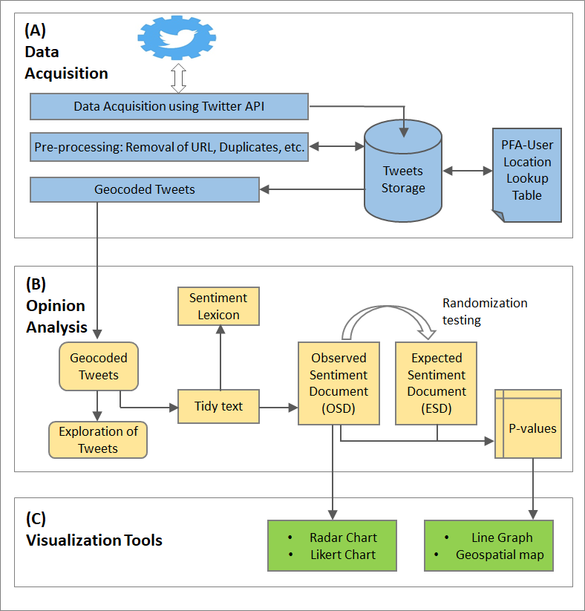

*Figure 1: Context-based Spatial and temporal framework for monitoring public opinion on policing*

3.1. Data Acquisition

The Twitter API is utilized in order to procure the publicly available tweets for our research. The API is a programmable tool that provides access to the public Twitter data that users have chosen to share with the world. However, the APIs pulls data (tweets) randomly from different locations around the world, leading to spurious database. We restrict the download to a narrow geography, leading to a robust database. Essentially, we define a geographical coverage in the form of a circle from which tweets must originate. This is achieved by using the ‘*search_tweets*()’ function of the ‘*rtweet*’ package in R.

The API searched for tweets that contain any of the specified keywords (or their hashtags) relating to the police or policing. These keywords are: ‘police’, ‘policing’, and ‘law enforcement(s)’. After the download, we geocoded each tweet to its respective spatial unit of analysis based on the user’s profile location. In this study, we use the operational units of the police forces in the UK, namely; the Police Force Areas, henceforth referred to as PFAs. The geocoding is completed by creating a ‘PFA-location-lookup’ table, which allow each tweet to be assigned to its respective PFA. Our ‘PFA-location-lookup’ table contains names of all cities, towns and villages across England and Wales. Created based on the UK ONS location gazette (ONS 2020), the lookup table contains a total of 35,604 names of locations.

3.2. Sentiment Analysis

The sentiment analysis is a text mining technique for computationally classifying opinions from a piece of text data into positive, negative or neutral, or some other more nuanced emotion like surprise, fear or disgust. Figure 1 shows the workflow for completing a sentiment analysis, with the annotation of the R packages (in double quotes) as well as the functions (in single quotes) that we employed in our own study. At the core of a sentiment analysis is the sentiment lexicon - a dictionary of words, which also shows their respective sentiment classification. Many spoken words express sentiment and can be collated together as a lexicons depending on the classification schemes. Most common lexicon is the uni-gram ‘BING’, which categorises a word into a positive, or a negative sentiment. By uni-gram we imply that the lexicon is based on a single word classification. In our study, we employ the AFINN lexicon, which provide a more nuance polarity classification by assigning a score indicating the degree of positivity or negativity of a word. The scores range from 5 (extremely positive) to -5 (extremely negative). The AFINN lexicon is used instead of the ‘BING’ lexicon in order to add more context to the tweet document classification. We understand that many tweets can contain multiple positive and/or negative words, all of which contribute to the overall opinion that a tweet expresses. It is then appropriate to classify a tweet as expressing either a positive or a negative sentiment by using the net sentiments across all sentiment words.

Another classification step that we took in order to ensure a more accurate scoring is to consider bi-grams classification (i.e. two words) in the cases in which a sentiment word is preceded by a negation word, such as ‘not’, ‘never’, ‘no’, or ‘without’. The score of such sentiment word is value in the opposite direction of the original word. For example, if the word ‘good’ which is scored as +3 is preceded by the negation word, such as ‘not’ (as in ‘not good’), then the sentiment of the word ‘good’ (in this type of scenario) becomes -3. Any tweet with zero a score of zero or that contains no sentiment words are considered neutral (non-subjective) and removed from the tweet document.

1. **Opinion Scores**

We define the opinion score of an area unit *i* for a given time window as the difference between the sum of all weighted positive tweets and the sum of all weighted negative tweets (Kuhn, M., 2008). This is given by the Equation 1:

|  |  |
| --- | --- |
|  | (1) |

Where, is the weight assigned to the tweets (e.g. based on the level of re-tweets or favorites), is the sum of positive sentiments and is the sum of negative sentiments. We ignore the weight i.e. in this study, for the lack of clear weighting function. Therefore, the final opinion score effectively becomes the difference between the total number positive and the negative tweets, following the AFINN classification. Given an opinion score (OP) of a spatial unit area *i*, we can state whether the public has a positive or a negative opinion about the subject matter. The public opinion in an area is positive if OP is the area has (+) sign, or negative if it has a (-) sign. We eliminate the neutral tweets from the tweet document.

1. **Document-Sentiment probabilities**

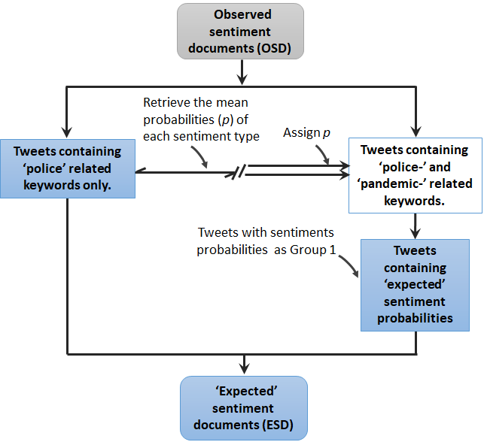To assess the impacts of the pandemic-related tweets on overall opinion on policing, there is a need to estimate the exclusive probabilities of sentiments for the tweets that relate to policing only, as oppose to tweets that relate to both policing and pandemic. The two-by-two matrix showing the probabilities of positive and negative sentiments in a given document is the ‘Document-sentiment probabilities. By assigning the probabilities from the tweet document relating to policing only to the document relating to policing and pandemic, we can derive an expected sentiment document, that assumes zero impacts of the tweets that contain pandemic.

Fig. 2. Deriving the Expected-Sentiment Document

The expected sentiment document is crucial for calculating the statistical significance of the computed OP across different PFAs. We simply compare the OP score derived from the ‘observed-sentiment document (OSD) (i.e. the original datasets) with the expected-sentiment document (ESD)’ based on Figure 2. We identify the ‘policing-pandemic-related’ tweets from the OSD by looking for tweets that contain the keywords or hashtags of words that references the covid-19 pandemic. These keywords include ‘*lockdown*’, ‘*corona*’, ‘*coronavirus*’, ‘*covid*’, ‘*covid-*19’, ‘*virus*’, and ‘*quarantine*’, ‘*infect*’, ‘*infection*’, etc. These keywords representing the pandemic context provide the context for the comparison.

**(c) Computing the P-Value of Opinion Scores**

The statistical significance (P-Value) of an observed OP score is required to make a judgment as to whether the observed OP score is beyond a change occurrence. To compute this p-value, we propose a non-parametric strategy based on randomization testing (*). We simply ask the question, “If expected opinion scores (i.e. *f*(E)) were generated under the null hypothesis (H0), how likely would we be to find any area with scores higher than the observed scores *f*(O)?”. For each PFA, the randomization testing involves generating a large number of ESD, otherwise referred to as “replicas”, , and generate a distribution of expected opinion score . Given the *f*\*(E) distribution for a given PFA, the respective *p*-value can be computed as , where is the total number of replicas created, is number of replicas with *f*\* value greater than *f*(O). As *f*(O) can be either be greater or less than *f*(E), we constructed two critical regions + α (i.e. two-tailed), allowing us to concluded whether the pandemic-related tweets have significantly impacted the observed public opinion in either direction. For the randomization testing, the more replicas generated, the more precise the *p*-value; a typical value would be *S* = 999. However, since the run time is proportional to the number of replicas, a lower value (e.g. 99) are often recommended.

3.3 Visualization

We need appropriate visualization tools in order to represent two important aspects of our results, namely; the temporal and the geospatial aspects of the derived opinion scores (Kucher et al. 2018). The temporal aspects relate to the potential changes in the observed opinion over time. Monitoring the changes could allow an analyst to better identify the factor that may be responsible for the observed change in public opinion. The geospatial aspect assumes that there are inherent spatial association between PFAs, particularly those found within the same policing region. For example, PFAs belonging to the same region may adopt similar operational policing tactics and therefore shape public opinion about policing similarly. These associations may manifest themselves in terms of similar patterns of opinion. Maps are best tools for revealing this type of associations (*).

We selected line graphs, radar charts and spatial maps in order to fulfil our visualization objectives. The tools are simple and efficient for representing complex multi-dimensional information. The line graphs allow us to visualize the changes in opinion over time. Both radar charts and geospatial maps are capable of representing multiple object attributes simultaneously, while also allowing any potential association to be visualized. In addition, we used likert chart to visualize the tweet categories and their rank order across the PFAs.

3.4 Reproducibility of Research

The source code of our research has been included as supplemental material, including the set up of Twitter API for data procurement. Our analysis source code (in the R language) is available as supporting information and online at <https://github.com/MAnalytics/..> . The source code and required data are both open source, so the analysis presented here can be repeated in its entirety using the source file.

4 Analytical strategy

The analytical strategy used in this study involves three steps, namely (i) Data exploration, (ii) Data analysis and Results visualization. These are described in details in the following subsections.

4.1 Data Exploration

Here, we provide an overview of our study area, the data and its characteristics.

(a) Study Area

Our study area is the geographical areas of ‘England and Wales’ - a legal jurisdiction covering two of the four constituent countries of the United Kingdom. The ‘England and Wales’ comprises nine policing regions, further subdivided into 43 police force areas (PFAs). The map in Figure 3 shows the policing regions in different colours, with grey outlines showing the boundaries of the PFAs. In this study, we derived 42 PFAs for the area because we merged the ‘City of London’ and ‘London Metropolitan’ PFAs due to overlapping boundary issues. The ‘North East’ region has the lowest number of PFAs with three PFAs, while both ‘Eastern’ and the ‘South East’ regions have the highest number PFAs of six each. According to the Crime and Disorder Act of 1998the PFAs work together to develop and implement strategies to protect their respective local communities. Based on the data download strategy employed in this study, a specified circle defined by a centroid {latitude '53.805, longitude -4.242} and a radius 350miles, covers the entire areas of England and Wales.

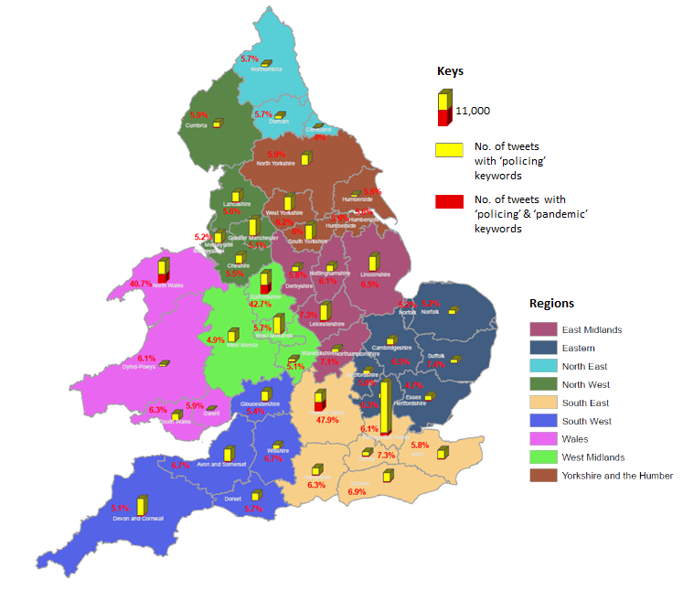Fig. 3. Map showing boundaries of policing regions and police force areas (PFAs) across England and Wales. The bars show the relative volume of cleaned tweets for each PFA over study period (i.e. from October 20, 2020 to January 20, 2020).

(b) Data and its Characteristics

We downloaded the publicly available tweets relating to the police or policing from October 20, 2020 to January 20, 2020 (3 months) for our study area. We carried out the data download twice a day (morning and night), extracting the tweets containing the specified police-related keywords within the last 7 days across the area. Following the downloads, we cleaned the data by eliminating all duplicates and spurious texts, including the punctuations, hashtags, emojis and stop words. We also removed re-tweets, but retain the replies (that contain the keywords) in addition to the organic tweets on the subjects. Then, we geocoded the tweets using the PFA-location lookup table. Our geocoding strategy is able achieves a 92% geocode of the tweets.

The inserted stacked histograms in Figure 3 show the total volume of the downloaded tweets downloaded per PFA, with the red sub-bar and the percentage values (in red) showing the proportion of tweets containing pandemic-related keywords. These values show that the majority of the PFAs has between 5–8% tweets speaking about policing in relation to the pandemic. The exceptions to these figures are the Staffordshire, Thames Valley, and North Wales PFAs with 42%, 47.4% and 40% police-pandemic tweet volume, respectively. The factors responsible for the sharp difference between these percentage values and those of the remaining PFAs are not readily apparent from the contents of the tweets.

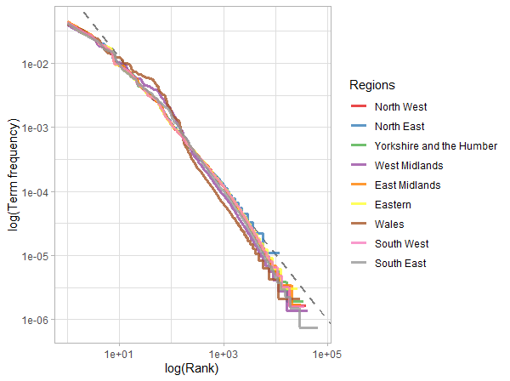A comprehensive descriptive summary of the data can be found in the supplementary material. The descriptive summary shows the skewness and kurtosis of the number of Twitter users (who generated the tweets). The skewness and kurtosis analysis allow us to examine the sampling of the tweets, and the results confirms absence of outliers, meaning that they are generated by a large number of users and not by a few prolific Twitter users. Then, we examine whether the tweet document follow the Zipf’s distribution (Zipf, 1936, 1946) – the famous frequency distribution expected of a natural language document. By Zipf’s distribution, we expect the frequency of words contained in the document to be inversely proportional to its rank in a frequency table. The distribution is most easily observed by plotting the data on a log-log graph, with the axes being log(rank order) and log(term frequency). Figure 4 is the distribution for our time period 1 dataset (i.e. from October 20, 2020 to November 19, 2020). The distribution plots of the remaining two time periods as well as the plots based on PFAs can be found in the supplementary material.

Fig. 4: Zipf’s distribution of our tweet document by policing regions (for Period 1).

Figure 4 shows that the tweet document of each policing region is close to the classic version of Zipf’s law (*). We see that all the nine regions have word frequency distribution similar to each other, and that the relationship between rank and frequency does have negative slope. The slope of the relationship is however not quite constant, and can be viewed in terms of a broken power law with three sections: the upper, the middle and the lower sections. By fitting a regression line, we can see what the exponent of the power law is for the middle section of the rank range. The deviations we see at high rank are common for many kinds of languages (*), because a corpus of language often contains fewer rare words than predicted by a single power law. However, the deviations at low rank are very unusual compared with a typical natural language documents. This is a result of the existence of many non-conventional or made-up words in tweets, therefore, affecting the trajectory of the lower section of the distribution. In summary, the tweet documents does not follow the Zipf’s law perfectly, but not close enough to state that the law approximately holds within our document of text.

4.2 Data Analysis

We divide the tweet document into three time period in order to monitor changes in opinion over time. We then perform the sentiment analysis and the associated statistical testing to identify the PFAs whose observation are unlikely to be due to chance. The time periods as defined as follow:

* Time Period 1: October 20, 2020 to November 19, 2020,
* Time Period 2: November 20, 2020 to December 19, 2020, and;
* Time Period 3: December 20, 2020 to January 19, 2021.

For each time period, we generate the OSDs for each PFA in order to allow the estimation of opinion scores across the study area. Thus, for each PFA, we have a time series (i.e. consisting of three data points) of observation. At the same time, we generate the ESDs for each PFA in order to allow the computation of corresponding statistical significance values. We use 999 replications in the randomization testing. Therefore, if, for example, seven of the 999 replicas have higher scores than the *f*(O), then the p-value of the O is = 0.008. In order to determine whether an observation is considered significance, we adopt the convention of 5% level, meaning each side of distribution is cut at 2.5% corresponding to a p-value of 0.025.

**5. Results**

We now discuss the results of our analysis in relation to our research questions.

**(a) What are the orientation of public opinions on policing across space over time?**

Fig. 5: Observed sentiment scores of PFAs for time period 1 to 3

[Explanation of results here]

(b) How have the concerns regarding COVID-19 pandemic impacted the orientation of public opinion on policing in space and time?



Fig. 6. Breakdown of categories of tweets and their sentiment per PFA

(c) Have the impacts of COVID-19 pandemic driven the opinion orientation in a significant fashion? And, are there spatial and temporal patterning to these impacts?

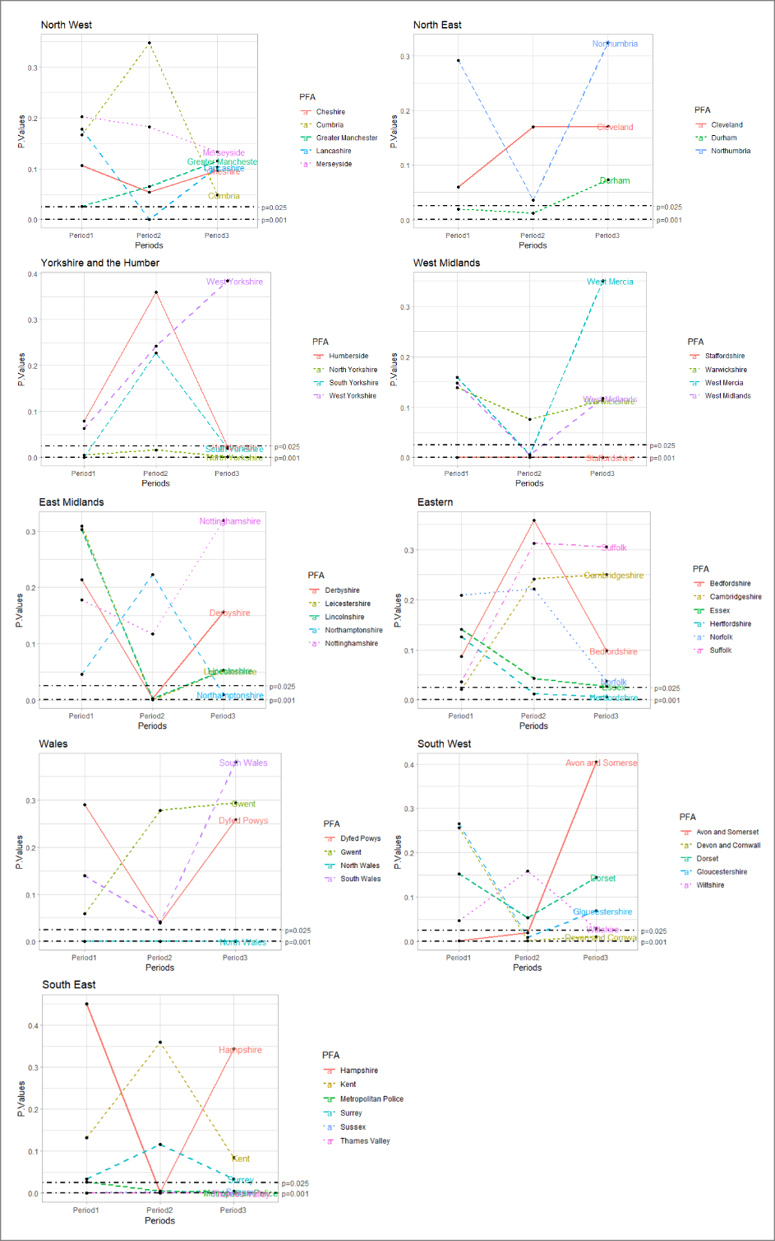

Fig. 6: Change in significance of observation

[Explanation of results here]

**6. Discussion**

**7. Conclusion**

Acknowledgements

References

Liu, B., 2012. Sentiment analysis and opinion mining. Synthesis lectures on human language technologies, 5(1), pp.1-167.

Istia, S.S. and Purnomo, H.D., 2018, November. Sentiment analysis of law enforcement performance using support vector machine and K-nearest neighbor. In *2018 3rd International Conference on* Information Technology, Information System and Electrical Engineering (ICITISEE) (pp. 84-89). IEEE.

Paul, D., Li, F., Teja, M.K., Yu, X. and Frost, R., 2017, August. Compass: Spatio temporal sentiment analysis of US election what twitter says!. In Proceedings of the 23rd ACM SIGKDD international conference on knowledge discovery and data mining (pp. 1585-1594).

Laufs J., Waseem Z. (2020). Policing in pandemics: a systematic review and best practices for police response to COVID-19. Int. J. Disaster Risk Reduct. 51:101812. 10.1016/j.ijdrr.2020.101812 Processes of Opinion change .

Langan, P., Greenfeld, L., Smith, S., Durose, M. and Levin, D. (2001), Contacts Between Police and the Public: Findings from the 1999 National Survey, Bureau of Justice Statistics, Washington, DC.

Bondurant, E. (1991), “Citizen response questionnaire: a valuable evaluation tool”, The Police Chief, pp. 74-6, November

Langan, P., Greenfeld, L., Smith, S., Durose, M. and Levin, D. (2001), Contacts Between Police and the Public: Findings from the 1999 National Survey, Bureau of Justice Statistics,

Washington, DC

Mastrofski, S. (1981), “Surveying clients to assess police performance: focusing on the police-citizen encounter”, Evaluation Review, Vol. 5 No. 3, pp. 397-408.

Mestre, J. (1992), “Community feedback program: twelve years later”, Law and Order, Vol. 40 No. 10, pp. 57-60.

Hand, L. C, and Ching, B. D (2019) Maintaining neutrality: A sentiment analysis of police agency Facebook pages before and after a fatal officer-involved shooting of a citizen. Government Information Quarterly 37(1):101420

S. S. Istia and H. D. Purnomo, "Sentiment Analysis of Law Enforcement Performance Using Support Vector Machine and K-Nearest Neighbor," *2018 3rd International Conference on Information Technology, Information System and Electrical Engineering (ICITISEE)*, Yogyakarta, Indonesia, 2018, pp. 84-89, doi: 10.1109/ICITISEE.2018.8720969.

Dende, K., 2014. Sentimental Analysis in crime detection: A case study of Kenya law enforcement agencies (Doctoral dissertation, University of Nairobi).

Xue J, Chen J, Chen C, Zheng C, Li S, Zhu T (2020) Public discourse and sentiment during the COVID 19 pandemic: Using Latent Dirichlet Allocation for topic modeling on Twitter. PLoS ONE 15(9): e0239441. <https://doi.org/10.1371/journal.pone.0239441>

Chukwusa, E, Johnson, H, and Gao, W (2020). An exploratory analysis of public opinion and sentiments towards COVID-19 pandemic using Twitter data. Research Square.DOI:   
10.21203/rs.3.rs-33616/v1 (preprint)

Y. Jiang, Z. Li, and X. Ye, (2020) ``Understanding demographic and socioeconomic biases of geotagged twitter users at the county level,'' Cartography Geographic Inf. Sci., vol. 46, no. 3, pp. 228_242, 2019.

Malik, M., Lamba, H., Nakos, C. and Pfeffer, J., 2015, April. Population bias in geotagged tweets. In Proceedings of the International AAAI Conference on Web and Social Media (Vol. 9, No. 1).

Pavalanathan, U. and Eisenstein, J., 2015. Confounds and consequences in geotagged Twitter data. arXiv preprint arXiv:1506.02275.

Kelman, Herbert C. "Processes of Opinion Change." The Public Opinion Quarterly 25, no. 1 (1961): 57-78. Accessed January 9, 2021. <http://www.jstor.org/stable/2746461>.

Kucher K., Paradis, C., and Kerren, A. (2018). The State of the Art in Sentiment Visualization. Computer Graphics forum. Vol. 37: 71-96.

Fong, E., & Chang, L. Y. (2011). Community under stress: Trust, reciprocity, and community collective efcacy during SARS outbreak. Journal of community health, 36(5), 797–810

Pang, B., Lee, L. and Vaithyanathan, S. (2002), “Thumbs up? Sentiment classification using machine learning techniques”, in Proceedings of the ACL Conference on Empirical Methods in Natural Language Processing-Volume 10, Association for Computational Linguistics, Stroudsburg, PA, pp. 79-86

Supporting information